**Institute of Technology Tralee**

**Computing Department**

**Object Oriented Programming 1**

**__________________________________________________**

**Problem Solving 6 – Some previous GUI CAs**

**(a)**

Write a Java program that contains a JFrame window. This window should contain 2 labels and 2 text-fields. It should have dimensions of 300 x 100 pixels. It should use a flow-layout style and the application should terminate when the close button is hit on its title bar. The labels should simply prompt the user for their height and weight. These values should be input by the user into the text-fields. When the user hits return on one of the text-fields, having input two valid numeric values, a message dialog should get displayed showing the Body-Mass Index (BMI) of the user correct to 3 decimal places. Hitting return on a text-field constitutes an ActionEvent, just like pressing a button, so treat it in exactly the same manner as this code-wise from the point of view of event-handling.

Note that there should be a little **validation** in the application. For example, if the user hits return on a text-field but no value has been entered into either text-field, a suitable error message in a dialog should appear to the user. Also, should the user enter a value of zero for the height, then a message dialog should appear telling the user that this value is invalid.

The formula for the BMI here is $BMI= \frac{weight}{{height}^{2}}$

**Note that you don’t need to worry about validating the height and weight values at all in any other sense, you can just assume numeric values have been entered for them.**

You should make use of the **appendix** of method definitions from the X: drive when answering this question.

For full marks your program should, along with a logically correct solution for the problem above, include comments and meaningful variable names.

Some sample runs of the program are as illustrated below.

**Sample Screenshots**

**After launching the application it appears as follows:**

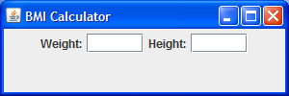

**If the user leaves either of the text-fields blank and then hits return, a message dialog will appear indicating this problem:**

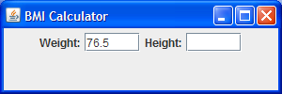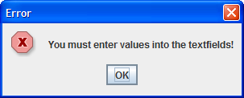

**If the user enters the value zero for the height then a message dialog will appear indicating this problem:**

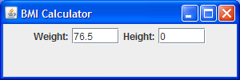 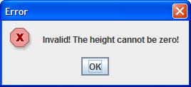

**If the user enters valid numbers into both text-fields then the BMI will get calculated and displayed to 3 decimal places on a message dialog:**

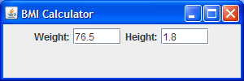 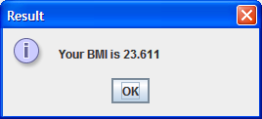

**(b)**

Write a Java program that contains a JFrame window. This window should contain a label, a text-field and a 2 buttons. It should have dimensions of 400 x 120 pixels. It should use a flow-layout style and the application should terminate when the close button is hit on its title bar. The label should simply prompt the user to enter a piece of text. This value should be input by the user into the text-field. The buttons will have the text “Length” and “Convert to Uppercase” on them respectively. When the user presses the “Length” button, then the length of the piece of text entered should be displayed on a message dialog. When the user presses the “Convert to Uppercase” button then the text entered should be displayed on a message dialog all in uppercase. If the user enters nothing and presses the “Convert to Uppercase” message then the message dialog should just display the message “You entered nothing!”

You should make use of the **appendix** of method definitions from the X: drive when answering this question.

For full marks your program should, along with a logically correct solution for the problem above, include comments and meaningful variable names.

Some sample runs of the program are as illustrated below.

**Sample Screenshots**

**After launching the application it appears as follows:**

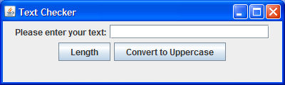

**The user enters a piece of text and then presses the “Length” button. A message dialog appears to display the length of the piece of text:**

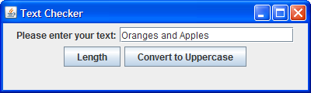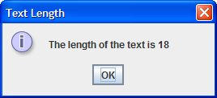

**The user now clicks OK on the first dialog and then presses the “Convert to Uppercase” button and another dialog appears, displaying the text in uppercase:**

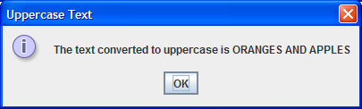

**The user now clicks the OK button and manually clears the text in the text-field using the “delete” key on the keyboard. Then the user presses the “Convert to Uppercase” button. In this case a different message will appear:**

